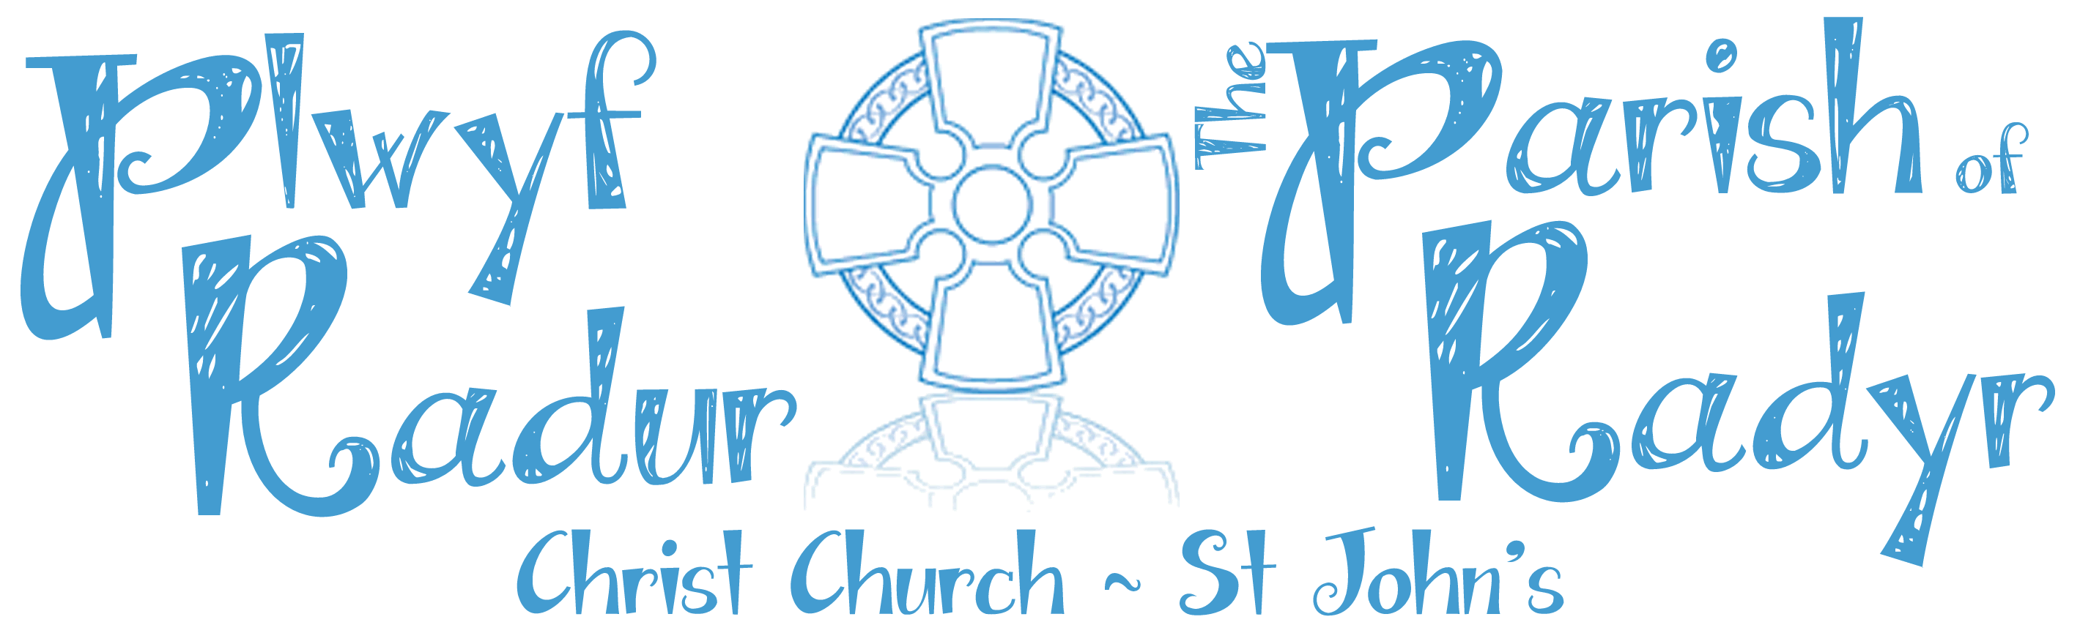

Getting Ready for Easter –

Hats & Afternoon Tea
Sunday 7th April
2.30pm

New schoolrooms, Christ Church
Come along & have fun making an Easter Hat
Adults £2 Children £1

